East Cheshire
CHESS Club

NEWSLETTER # 18, 7th December 2016

1. Best wishes to Bill
At the club night last Wednesday 30th November we bade a fond farewell to Bill Tait, our Treasurer and long-time stalwart of the club, with our Chairman Geoff Clarke leading a toast and saying a few words of thanks. Bill has been with the club for 8 years now, which have included stints as C-team captain and as Treasurer since 2014. He’s now moving to the Harrogate area to be closer to his children and grandchildren and his easy-going and friendly manner at East Cheshire will be much missed. With several clubs to choose from in Bradford and around, Bill plans to carry on his chess in the white rose county and hopefully surface again in these parts for the odd weekend congress.

Thanks again Bill, and all the best!

2. East Cheshire Christmas Social Evening on December 14th 2016
Our pre-Christmas social will take place on Wednesday 14th December (so a week on Wednesday at time of writing). The usual format will apply – arrive with some food and drink for 7:30 so Phil can get us off and running with round 1 at 7:45, and there'll be the usual long break in the middle to enjoy our combined food and drink and to chew the fat.

3. Stockport Chess Club Christmas Buzzer Tournament.
Stockport Chess Club are holding their annual Buzzer Tournament on Tuesday evening 20th Dec at the Ladybrook Pub, which is close to Bramhall Park. For the uninitiated: this is where a buzzer sounds every 10 seconds, and if it’s your turn to move, you need to do so straight away. Trickier than it might sound! Any player from any club is very welcome. They can enter beforehand by email or come along on the night. Details are on the league website: http://www.stockportchessleague.org.uk/index.htm

4. Treasurer and Secretary roles for next season
With Bill moving, but with much of the activity in the Treasurer role taken care of for the 2016-2017 season, Bill has very kindly offered to continue in the role if needed until the AGM in May; however, if a willing volunteer can be found in the interim, all the better.
Additionally, due to a combination of changes in my personal circumstances, I will be unable to be secretary for next season, and so following the AGM in May 2017, there will likewise need to be a new secretary.
This is therefore to give advanced notice that in the months to come we will need for members to come forward to take on these roles for the 2017-2018 season. Myself and Bill will be happy to talk anyone who’s interested through what’s involved in each position.

5. Stockport League update
A special mention here for The C-team, which has come romping out of the blocks this season with 3 wins from 3, with relatively new additions “the Steves” (Kelly and McCall) taking to Division 3 with aplomb, and the old guard getting some strong results themselves. Clearly the duffer who was at the C-team helm last season was only holding them back?

In the club Matchplay competition, of those players on track to have played in the required 7 team matches over the course of the season, the following players are currently in the top positions:

McCall, Steve | 5 | 4 | 80%
Kelly, Steve | 3 | 2 | 67%
Tait, Bill | 7 | 4.5 | 64%
McKie, Jim M | 4 | 2.5 | 63%

There is a large chasing pack so it’s all to play for…

6. East Cheshire successes at local congresses
It’s been a fine start to the season by club players at weekend tournaments in the region….
Apparently a man for all seasons and time controls, Paul Bamford notched his second tournament win of the year at the Crewe Chess Congress in the middle weekend of October, following on from his performance at the Leyland Rapidplay in February (see below). Paul was taking part in the Intermediate section (for players graded below 135), again winning outright and again for the loss of just half a point with an outstanding score of 5 ½ out of 6. This time it was a weekend congress, with players getting 1hr 40 minutes plus increments for each game.
Well done again Paul! That’s two rounds you owe the rest of us now (yes, we are counting).
And then at the start of November, Steve McCall was joint winner of the Knights section (grading below 135) of the Bolton Rapidplay. Not to be disheartened with a loss in the first round, Steve bounced back with wins in all his remaining 5 games, beating and therefore leapfrogging me (how unsporting!) in the final round to share the top prize, with me finishing joint third. Steve only joined the club towards the end of last season, but clearly found some sharpness and form in the rapidplay league over the summer.

Hats off Steve!
Our closest weekend event of the season will be the Stockport Rapidplay on Sunday 29th January – for this and other upcoming events (before and after), take a look at the table on the club website: http://www.eastcheshirechessclub.org.uk/links/events/

7. Christmas closure.
The club will be closed on Wednesday December 21st and 28th, but will re-open on Wednesday January 4th when there is a home match for the A-team against Holmes Chapel.
Best wishes for an enjoyable Christmas and for a happy and healthy 2017.

Myles Heywood (Club Secretary)

And here are some puzzles for you to solve over Christmas….

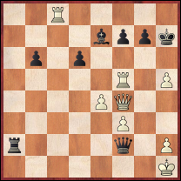
- White to move – find the cleanest way to win the game and with it retain your crown as World Champion…

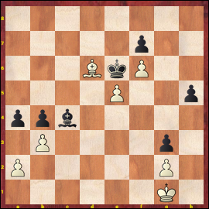
- Black (to move) and wriggle a pawn home

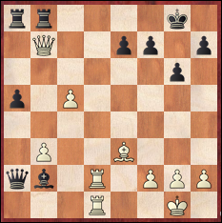

- White to play and win

